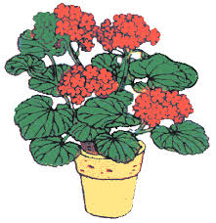Darien Historical Society
Darien Woman’s Club

PLANT SALE
Pick-Up Date: Saturday, May 1, 2021

Where: On the Grounds of Old Lace Schoolhouse and Museum
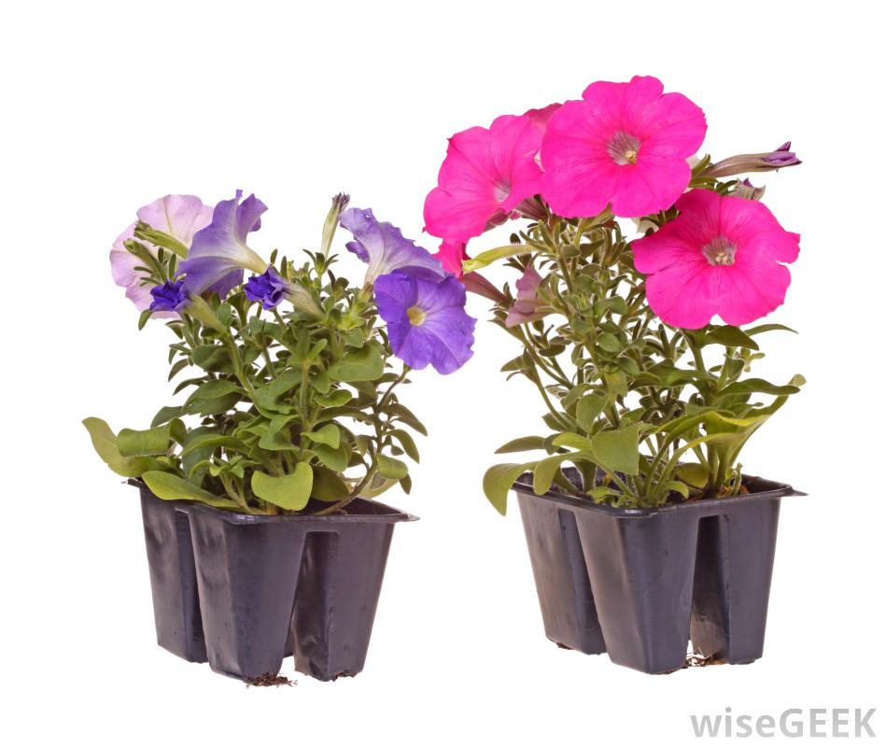 7422 Cass Avenue
Darien
Pick-Up Time: 10 A.M. to 12 Noon
Sale Details:
Plants must be pre-ordered and paid for when the order is placed.
Plants must be picked up on the day of the sale. Drive-Thru Plant Pick-Up!
PLANT PRICES UNCHANGED FROM LAST YEAR!
All proceeds will go towards the efforts of
both organizations to benefit the community.
* * * * * * * * * * * * * * * * * * * * * * * * * * * * * * * * * * * * * * * * * * * * * * Order Form for Plants Due by April 8th
Please Complete the Information Below and Attach to Your Order Form

Name (Please print) _______________________________________________________
Address __________________________________________________________________
__________________________________________________________________
Phone Number (_____) ______-_______________
Email Address ____________________________________________________________
Please make checks payable to the Darien Historical Society.
7422 Cass Avenue
Darien, IL 60561

